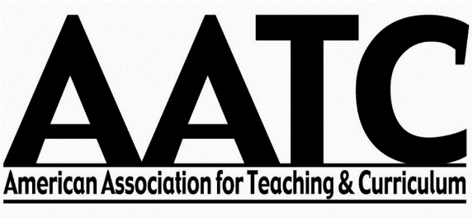

Graduate Student Scholarship Application
AATC Annual Conference – Denver, CO 2017

A small number of scholarships are available to help graduate students attend the AATC Conference. In order to be considered for a scholarship, please complete this form. Scholarships are issued depending upon expressed need, ability to work at the conference, and available funds.

Typical responsibilities include providing approximately 8 hours of assistance divided between the following tasks: assisting at the registration desk, facilitating conference sessions, helping with room setup (when appropriate), collating materials, monitoring book fair exhibits, and other duties as assigned. When not assisting with conference logistics, scholarship recipients are encouraged to enjoy the conference by attending sessions and networking with other AATC members.

If interested in assisting at the AATC’s Annual Conference in Denver, CO (2017), please complete all sections of this form and return it to Dr. Dana Haraway no later than September 8, 2017.

You will be notified of scholarship award no later than September 18, 2017. If you are seeking a scholarship, please wait to pay your registration fees (if possible) until after you receive notification and your scholarship award has been applied.

APPLICATION PROCESS

- Complete the Personal and Academic Information section
- Provide a Statement of Need and Interest
- Sign and date the form
- Request that your advisor or program chair complete the Verification of Student Status form
- Save and send the entire document to Dr. Dana Haraway (harawadk@jmu.edu) no later than September 8, 2017.

Personal and Academic Information

Name _______________________________________________________________________
Last First MI

Address _______________________________________________________________________
Number Street Apt.

________________________________________________________________________
City State Zip Code Country (if applicable)

Phone ____________________________________

Email _____________________________________

Current Institution ________________________________________________

Degree Program (circle one) M.Ed MS.Ed. Ed.D. Ph.D. Other:

Degree or Concentration: ________________________
Statement of Need and Interest

In the box below, please provide a short statement of need and interest. Include your travel plans and availability to assist with the conference Wednesday, Thursday, Friday, and/or Saturday. Please remember that our expectations are that you are interested in dedicating time and effort to help our conference be a success:
(Text Box Expands)

______________________________________ __________________
Student Signature Date

Verification of Student Status

I verify that ______________________________ (name of student) is currently a registered student at

__________________________________ (name of institution).

Program Name: __________________________________________________

Level: __________________________________________________ (e.g., M.Ed., Ph.D.)

____________________________________________________
Printed Name of Advisor or Program Chair

____________________________________________________ _________________
Signature Date

