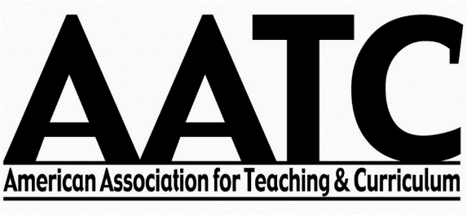

AATC Executive Council Meeting Minutes
October 13, 2016
Grand Rapids, MI
Time: 7:30 – 8:50 am
Location: Boardroom

- Welcome and Approval of Agenda

- Announcements and General Updates
  - President William White called the meeting to order. He welcomed the new members of the Executive Council.

- Committee Reports – Questions

  - Curriculum and Teaching Dialogue
    - David Flinders reported on the status of CTD. There were 42 uninvited submissions and 18 accepted manuscripts.
    - Kate Kauper explained the process for selecting the Francis P. Hunkins Distinguished Article Award. There were two awards this year: Elizabeth Dorman and Paul Parkinson.
    - Additional journals need to be ordered and disseminated to Kate Kauper to be shipped to authors.
    - The council discussed whether or not we should ship the journals directly.

  - Conference Update
    - 130 total number of conference proposal submissions. 118 were accepted.
    - 1/3 of conference participants are core members. 1/3 of participants are graduate students.
    - AATC gave out $1200 for graduate student support and collected $160.
    - The council discussed the lack of refund policy—especially for participants who back out of the conference at the last minute. This policy needs to be available to participants at the time of conference registration. There needs to be a “point person” to coordinate for extenuating circumstances. The council agreed that such a policy needs to be established.

  - Budget Update
    - In April of 2016, we transferred $45,013.55 into the new Bank of America checking account.
    - To date, we have spent $8,012.16 on regular business expenses (Paypal account, Spring meeting, CTD proofing/publishing, conference programs, etc.)
    - We have deposited $11,814.80 of conference registration fees into the account.
    - We currently have $15,452.58 in conference registration fees in our Paypal account.
    - The current total in our Bank of America checking account to date (10/11/2016) is $48,816.19.
    - For a detailed record of expenses paid and deposits made see Appendix A (Account Transactions Apr-Oct).

  - Future Conference Locations Discussion
    - In 2017, the annual conference will be held in Denver, Colorado. In 2018, the conference will be held in Texas. The council discussed possible conference locations in Texas. The council also discussed establishing an ad-hoc committee to examine alternative conference models (e.g., no food/beverage minimums, no set # of rooms, held outside a hotel, etc.) Several concerns were brought up about the timeline for pursuing an alternative model. The committee agreed that they would continue the current conference model for 2018, and then pursue alternative options for 2019.
    - Kevin Cloninger motioned to establish an ad-hoc council to examine alternative conference models. Megan Kennedy seconded the motion. The council voted to approve the motion.
    - The council discussed the need to clearly articulate the roles and responsibilities of Executive Council members, program chairs, etc. with respect to annual conference preparation. The council also discussed the need for greater communication and collaboration between conference chairs (from year to year).

- Unfinished Business
  - Chara Bohan recommended that the Executive Council be insured for the decisions made by the council. Liability insurance would be about $800 annually. The council agreed to examine this possibility.
  - President White thanked the members who are rotating off the council for their work and welcomed the in-coming council members.

- New Business
  - The committee reviewed the dissemination of graduate student scholarship funds. One graduate student (Joseph Bolz) did not receive support. After discussion, Brad Conrad motioned that graduate student Joseph Bolz be approved for a graduate assistant scholarship for his work at the book fair. Joseph Flynn seconded the motion. The motion carried.
  - Council members Joseph Flynn and Brad Conrad recommended that a graduate student be hired to promote the organization through social media. Council member John Pecore suggested that we ask students at the graduate student meeting.
  - President White recommended that we consider ways to attract returning members, especially graduate students (e.g., reduced conference rates for graduate students returning as full-conference participants, etc.).

- President White moved to adjourn the meeting.

